Bump Note

Dear Parent / Carer,

Name…………………………………………………………………………..
Your child has sustained a head injury today at ……….am/pm and has been monitored since the accident.

Details……………………………………………………………….……………………………………………………….……………….………………………………………………………………..……………………………………………………………………………………………………………………………………………………………………………………………………………………………………………
………………………………………………………………………………………………………………

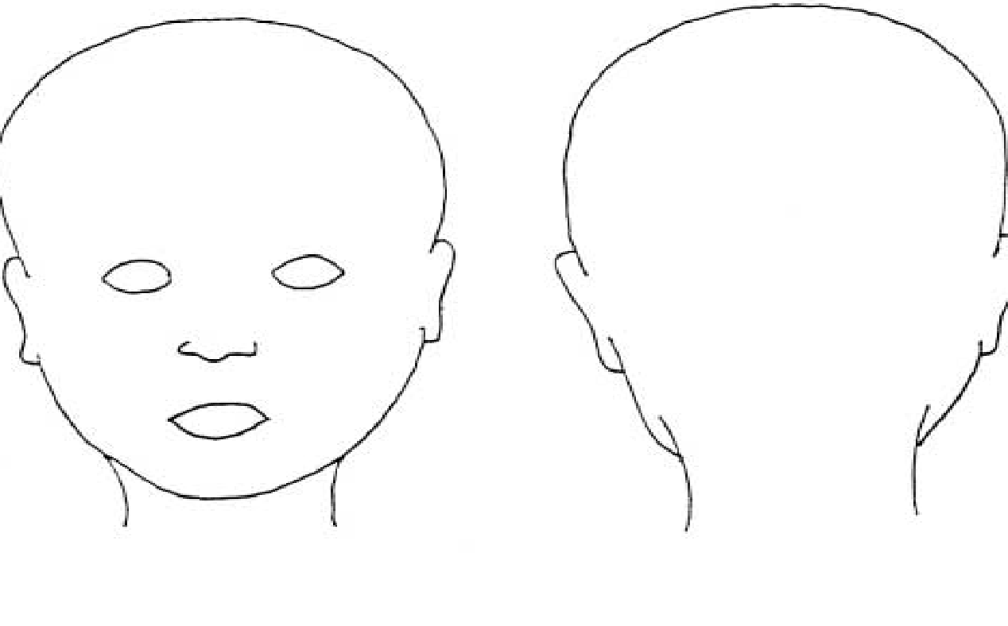
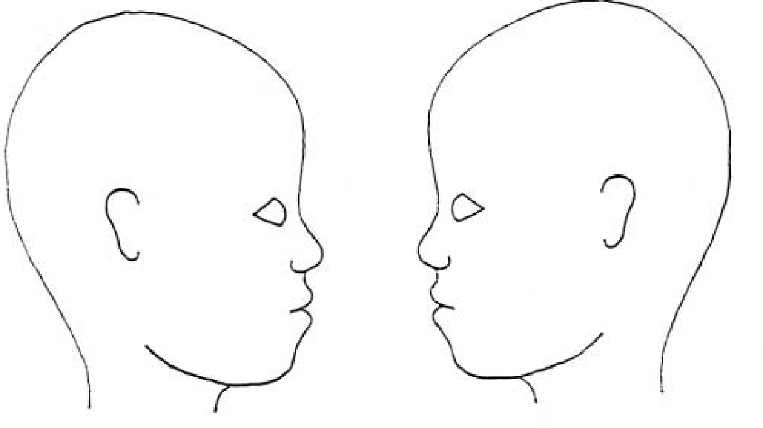
Front Back Right Left

If any of these symptoms are present, you should call the emergency services(999 / 112) or NHS Direct on 111.
- Headache that gets worse or is still present over six hours after the injury;
- Difficulty in staying awake, or still being sleepy several hours after the injury.
- Nausea and vomiting;
- Unconsciousness or coma;
- Unequal pupil size (anisocoria);
- Confusion or dizziness;
- Fluid or blood coming from the ears or nose;
- Bleeding from the scalp that cannot be quickly stopped;
- Inability to use part of the body, such as weakness in an arm or leg;
- Difficulty seeing or double vision;
- Slurred speech;
- Seizure.

Signed …………………………………

